# Discovering meteors from images using ML

## Objective

Meteors pose a significant multidisciplinary status due to their physical and chemical links with atmosphere and its various components. Their study helps understand wide range of hypervelocity physics, including physics of extreme ablation under varying atmospheric densities etc (1). Given their importance it is imperative to harness the study with recent advancement in technology and artificial intelligence. One of the such subdomains is detection of meteors through computer vision (2) which was classically done through radio frequency. This project will apply state of the art computer vision algorithms to classify and detect meteors from image data.

## Project Details:

The aim of this project is to apply computer vision algorithms for identification of meteors in sky images. The dataset has been provided by Bayfordbury observatory and comprises of image JPG file along with corresponding .FIT files. The dataset will be analyzed and explored to further perform image classification on it. In addition to it, this project will also include comparison of recent 3 machine learning models and will further evaluate their results.

## Ethical Consideration:

The dataset and any other information provided by the Bayfordbury observatory will solely be used for this project and will not be posted elsewhere. Images will only be analyzed for image classification task and the results will be various qualitative & quantitative methods commonly used for image classification.

## Project Plan:

This project will comprise of following tasks:

* Data Collection & Cleaning: Collection of adequate number of images needed for a typical classification task and exploring suitable data cleaning methods for this particular dataset
* Literature Review: Research on current methods and state of the art algorithms being used in computational astrophysics.
* Data Labelling: Binary/Multi Category Labelling of the dataset
* Exploratory Data Analysis
* Application of Image Classification Algorithms
* Evaluation of results from 3 different algorithms
* Report Writing

The tentative dates and plan is shared in the chart below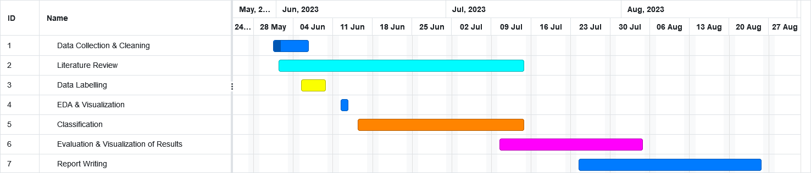

## References:

1. Bektesevic, D. and Cikota, A. (2014) Detection of Meteors in Sky Survey Image Databases. Available at: http://vinkovic.org/CV/papers/Bektesevic-BDiS-2014.pdf (Accessed: 29 May 2023).
2. Cecil, D. and Campbell-Brown, M. (2020). The application of convolutional neural networks to the automation of a meteor detection pipeline. *Planetary and Space Science*, [online] 186, p.104920. doi:https://doi.org/10.1016/j.pss.2020.104920.